**AWS IAM User and User Group for segmentation of Development and Production Envornment**

**AWS IAM Users and User Groups can be used to segment access between Development and Production environments, ensuring that users have the appropriate permissions based on their role and environment, thereby enhancing security and operational control."**

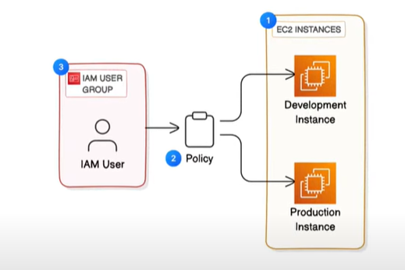

**Create**

1. **EC2 Instance**
2. **IAM policy**
3. **IAM Users and User group**
4. **AWS account alias**

**Launch 2 EC2 Instances to boost compute power – for expecting more traffic into the website**

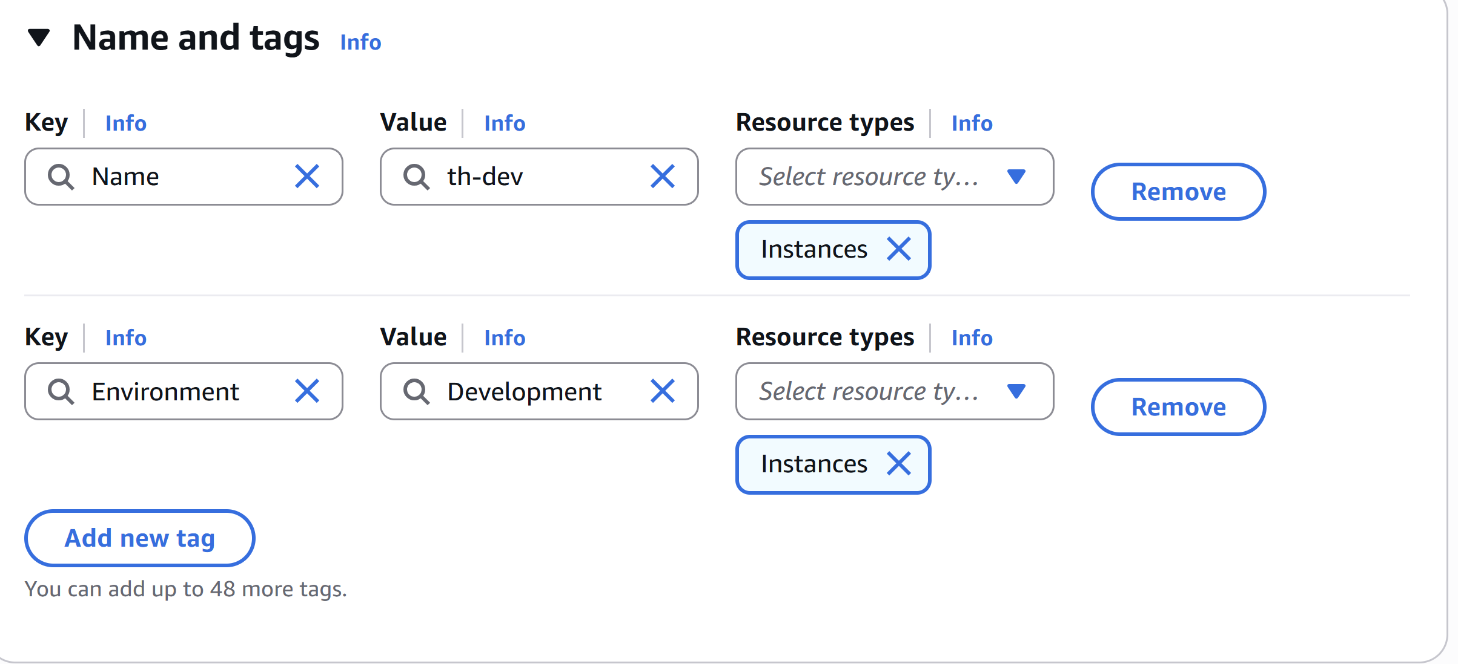

**Tags are organisational tools that let you label and categorize AWS resources using key-value pairs, making it easier to manage, identify, filter, and automate tasks related to cost allocation, security, and resource management.**

**Tags for two EC2 instances**

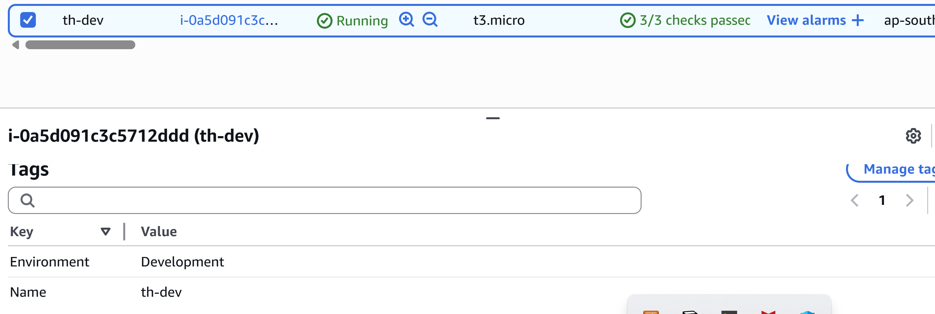

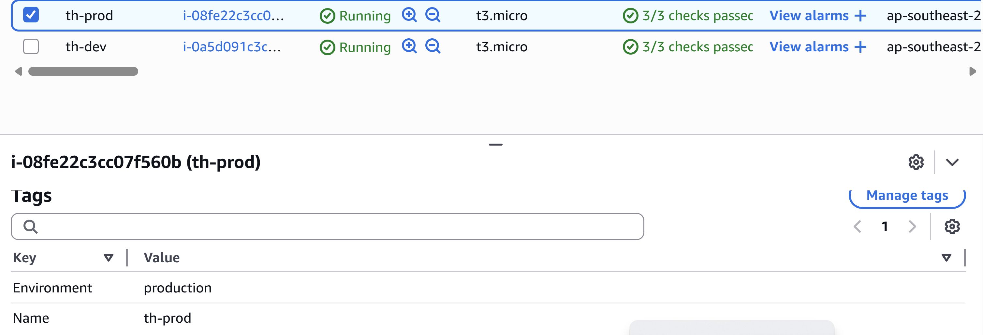

**Use IAM policy to control access to Development environment and not in the production environment**

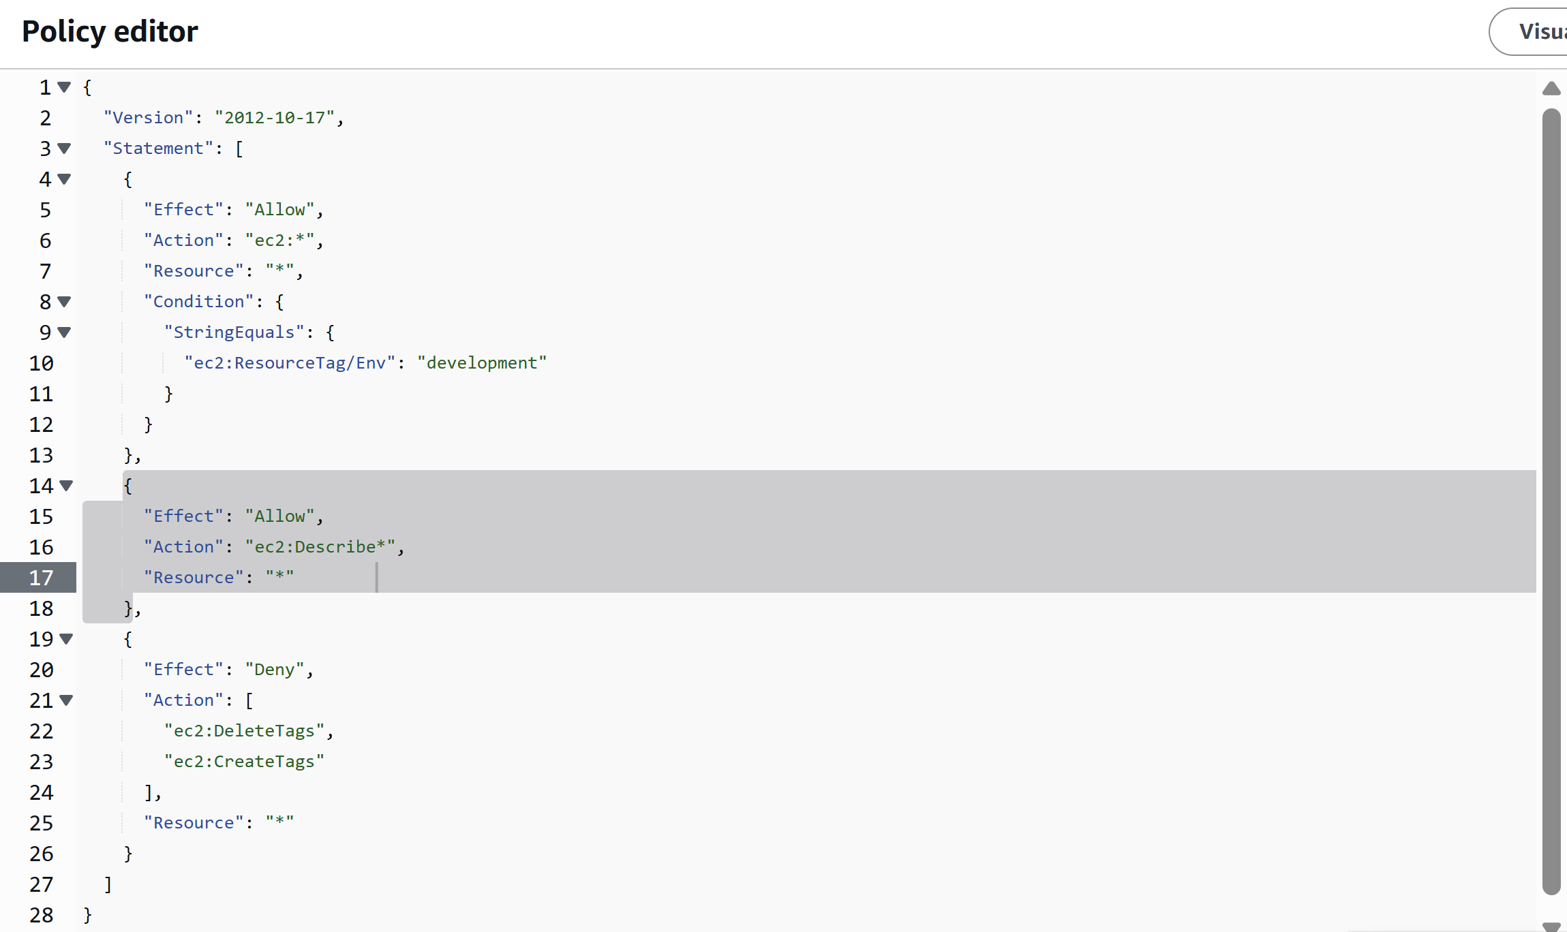

**The Effect action and resource attributes in JSON policy is whether the policy is Allowing or denying the Action(Effect) . What the policy holder can or cannot do(Action)and the specific AWS resources that the policy relates to**

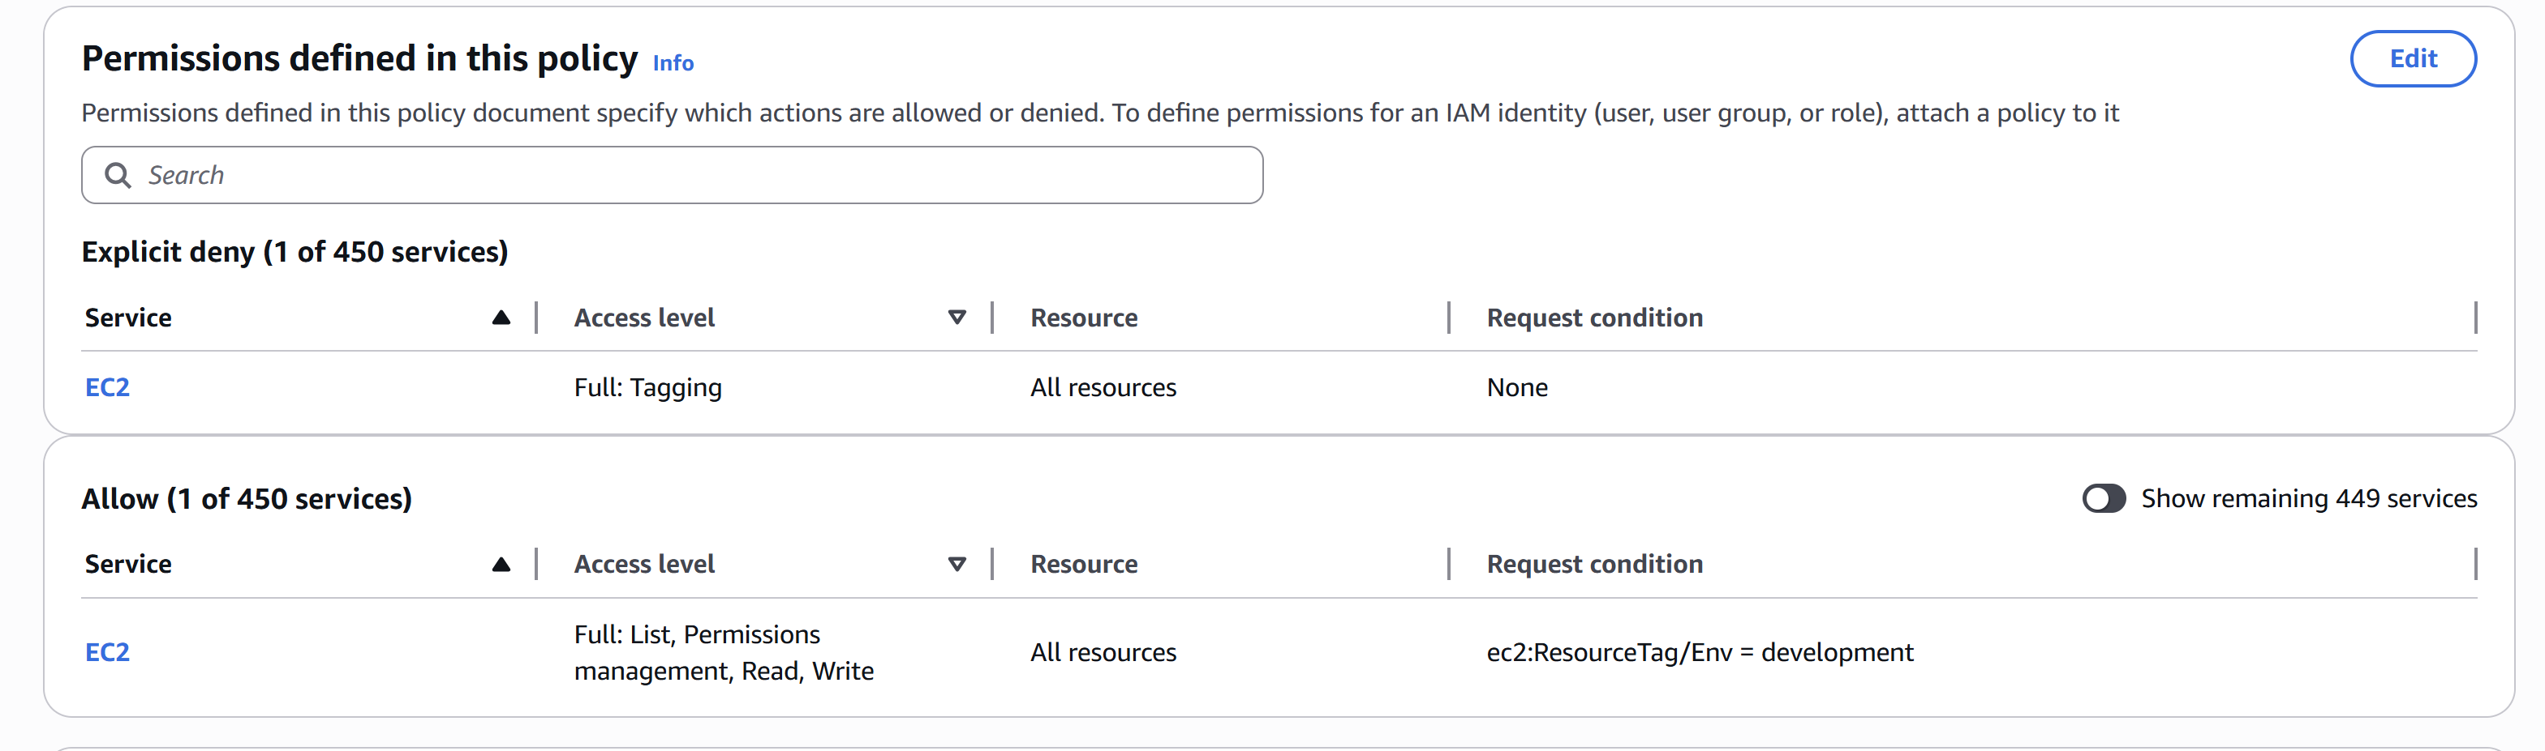

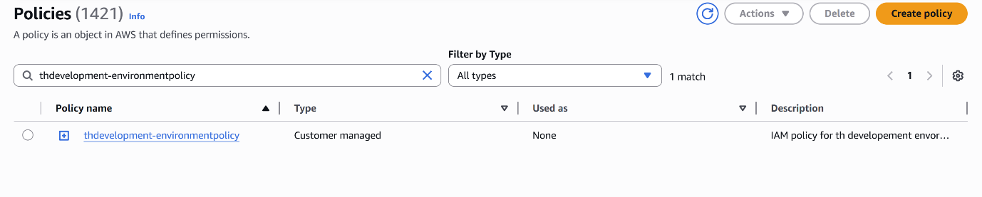

**ACCOUNT ALLIAS**

**Account Alias in AWS allows you to create a user-friendly name for your AWS account, replacing the default account ID in the sign-in URL. This makes it easier for IAM users to access the AWS Management Console with a recognizable and branded URL**

**AWS IAM USERS and USER GROUPS**

AWS IAM Users and User Groups allow secure access management within AWS.  
IAM Users are individual identities with specific credentials and permissions, while User Groups are collections of users that share common permissions, making it easier to manage access at scale.

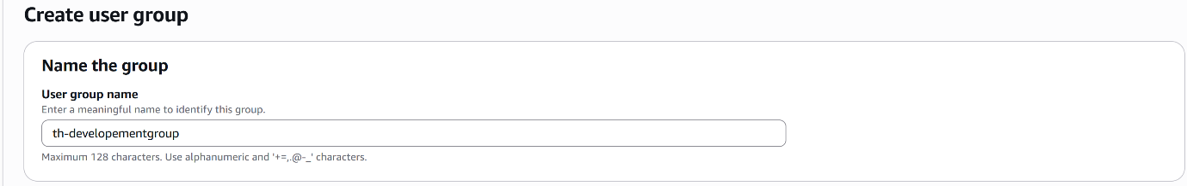

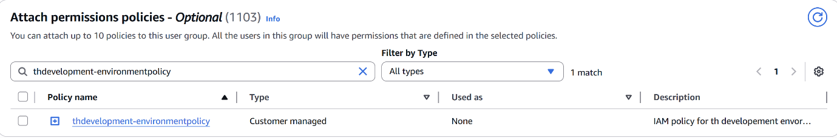

**The Development Users will be able to access EC2 Instances but will not be able to delete or add Tags for any instance at all.**

**Add Users to the User Group**





